**TUGAS 2 KELOMPOK**

**S.A. - Pemrograman Berbasis Objek**

Anggota :

1. Fahdiarsyah Hilmy Hidananto (A11.2021.13730)
2. Muhammad Rayhan M. A. (A11.2020.12443)
3. Fikhri Wahyu Ramadhan (A11.2018.11309)

**Class Diagram**

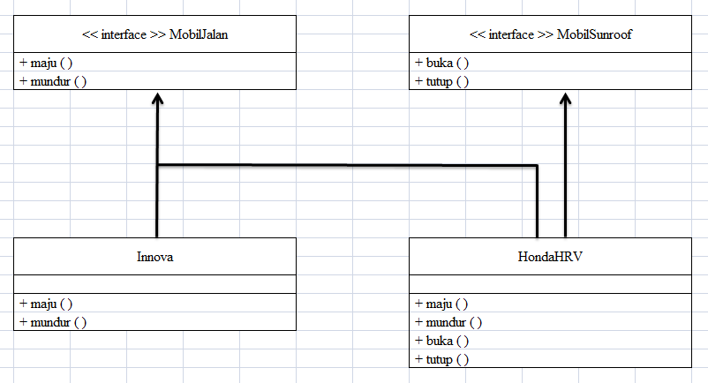

**Code Program**

1. **MobilJalan.java**

// Interface

interface MobilJalan {

abstract void maju();

abstract void mundur();

}

1. **MobilSunroof.java**

// Interface

interface MobilSunroof {

abstract void buka();

abstract void tutup();

}

1. **Innova.java**

class Innova implements MobilJalan {

public void maju() {

System.out.println("Mobil Innova maju...");

}

public void mundur() {

System.out.println("Mobil Innova mundur...");

}

}

1. **HondaHRV.java**

class HondaHRV implements MobilJalan,MobilSunroof{

public void maju() {

System.out.println("Mobil kijang maju...");

}

public void mundur() {

System.out.println("Mobil kijang mundur...");

}

public void buka() {

System.out.println("Mobil HRV sunroof terbuka");

}

public void tutup() {

System.out.println("Mobil HRV sunroof tertutup");

}

}

1. **TestMobil.java**

public class TestMobil {

public static void main(String[] args) {

MobilJalan innova = new Innova();

MobilJalan hrv = new HondaHRV();

MobilSunroof sunroofhrv = new HondaHRV();

test1(innova);

test1(hrv);

test2(sunroofhrv);

}

static void test1(MobilJalan mj) {

mj.maju();

mj.mundur();

}

static void test2(MobilSunroof ms) {

ms.buka();

ms.tutup();

}

}

**Hasil Program**

1. **TestMobil.java**

